

**Karate Northern Ireland**

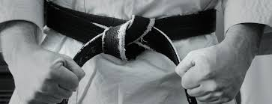

**2024 Referee Seminar**

**Sunday 28th January 2024.  
St. Josephs Parish Hall, 56 Greystone Road Antrim BT41 1JZ  
10.00am – 3.30pm   
for**

**National Referees & Judges, New Judges & Administration Officials.  
Registration: email**[**karatenorthernireland@hotmail.com**](mailto:karatenorthernireland@hotmail.com)**by 15th January 2024.**

**------------**