Karate Northern Ireland
www.karatenorthernireland.co.uk

The Official Northern Ireland Open
Karate Championships
Belfast, Sat 27th^{th} April 2024.

Dear Mr/Ms President,

It is with pleasure that I invite you on behalf of Karate Northern Ireland to The Official 2024 Northern Ireland Open Karate Championships. The event is held in Queens (University) PEC, Botanic Gardens, in the centre of Belfast https://www.queenssport.com

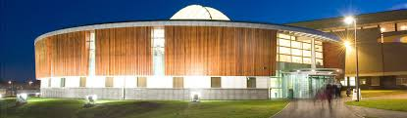

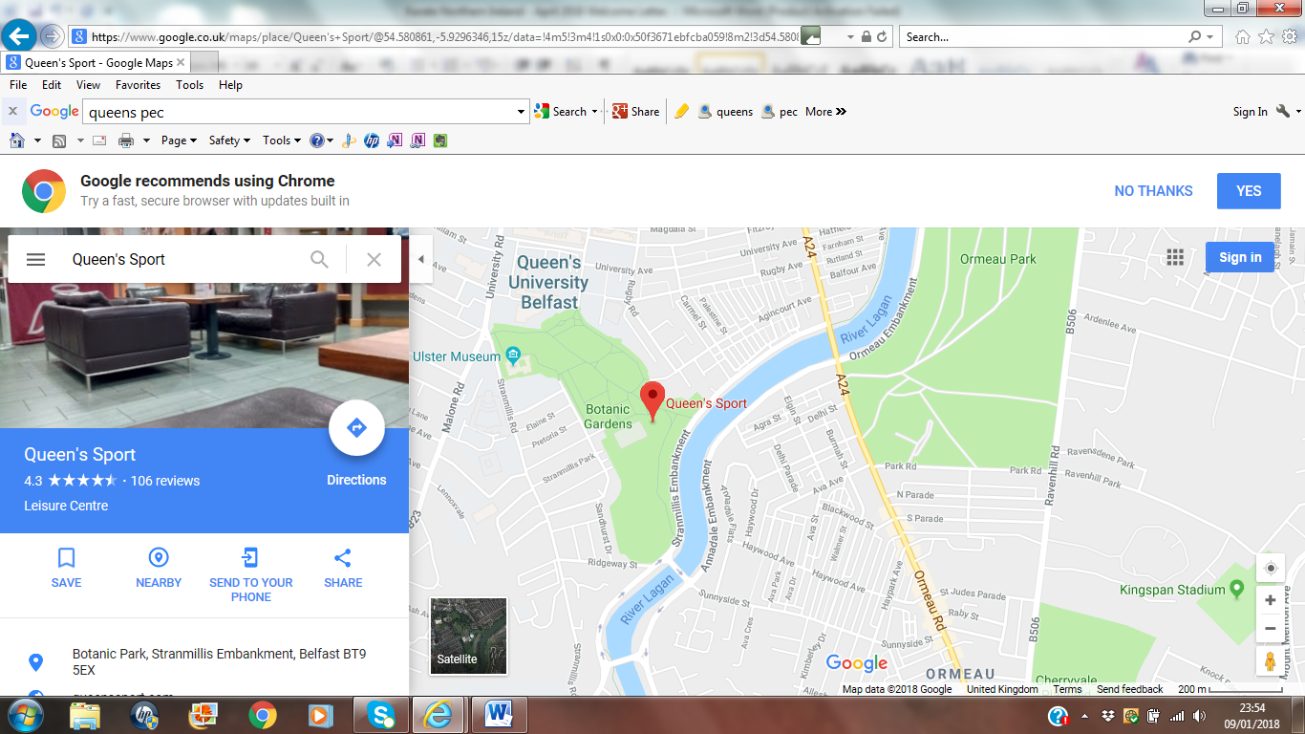

Entry is by OpenReg Online Registration only. Familiarise yourself with the system as soon as possible.
Please note that photograph/age/height/weight must be entered for each contestant.
Closing Date for Entry and Payment is midnight Sunday 14th April 2024.

The Event:

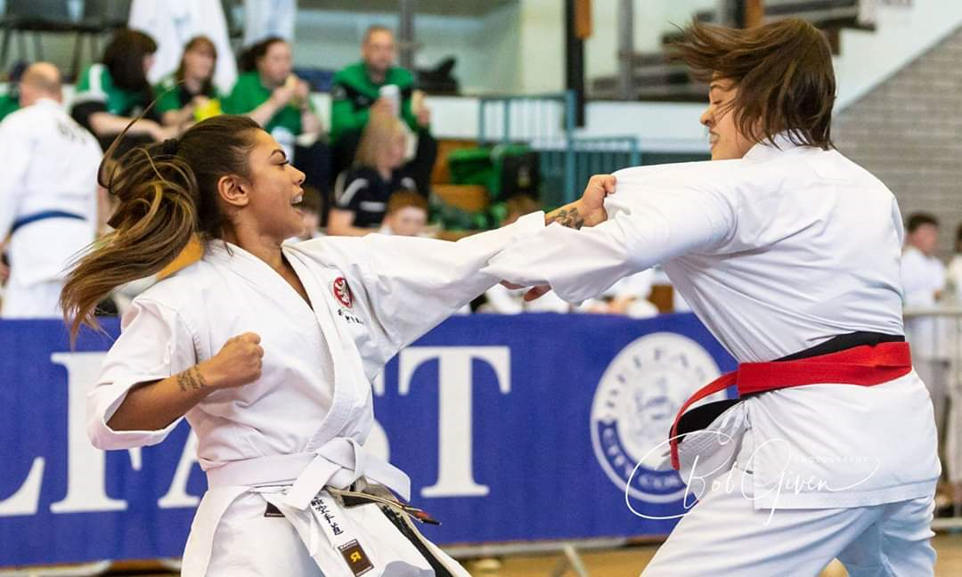

The event is open to all bone fide karate associations irrespective of affiliation. It will start at 9.00am and run straight through to the finish at 6.00pm. Each area will close down consecutively for 30mins 12.00 – 2.00pm.

Dojo Holding Area:
Competitors can only enter events through the Dojo Holding Area accompanied by a KNI Official. Competitors competing in the morning must be in the Dojo Holding Area (on Level 1) overlooking the competition hall at 8.00am for registration and event preparation. Only competitors and coaches are permitted in the Dojo Holding Area. A KNI official will bring all competitors to the tatami when they are due to compete. Competitors will only bring their protective equipment with them to the tatami. Tracksuits and water bottles etc. are not permitted inside the competition area. After each category there will be a medal presentation. After each category competitors will be taken from the tatami and returned to the Dojo Holding Area to prepare for their next event.

Weigh-in, will take place in the Dojo Holding Area from 8.00am onwards.
Height check, will take place in the Dojo Holding Area from 8.00am onwards.
(Weigh-in and Height check can take place the previous evening (Fri) in the stadium main hall between 6.00pm – 9.00pm. Teams wishing to do so must advise the organiser if they wish to avail of this facility.

Entries:
1) OpenReg Online Registration and Payment must be received by the closing date. Entries will not be accepted without payment; we do not want cash payments on the day. Late entries up to 14th April will cost double the normal entry fee.
2) Association registrations must contain qualified Referees/Judges/Working Officials as well as Competitors and Member to Member Insurance Certificate. We will not accept entries from associations with only competitors.

For Online Registration and up-to-date Rules go to: https://reg.openentry.net/openreg/set-online/veranstaltung_info_main.php?active_menu=calendar&vernr=38#a_eventhead (registration will be available from 1st January 2024 incl. Categories & Costs). (KNI Rules are found at the top of the Events page, download, print-off and familiarise yourself with them).

Entry Tickets:
Spectator entry tickets will cost £5 each and can be purchased at the door on the day. Competitor paid-up tickets and event numbers will be provided to the registered team manager or coach the evening before at the stadium between 6.00pm and 9.00pm or at the main hall entrance from 8.00am on Saturday morning.

Meals:
Queens PEC has a modern snack bar/restaurant serving light meals and refreshments. You can bring your own food into the arena etc. Karate Northern Ireland will provide lunch and refreshments for Referees, working officials and guests. Referee lunches will take place between 12noon – 2.00pm.

Attention:

- Coaches are reminded to read exactly the requirements of the categories regarding age, height, weight and experience, and overall suitability. Coaches are asked to be careful when entering a contestant at the lower end of a height/grade/weight category simply because he is within the age grouping. The Chief Referee may refuse to allow a contest if he deems it unsafe. Officials will not amend incorrect entries. Contestants entered in the wrong category will be disqualified, refunds will not be provided.
- Protective equipment used must be as laid down in the Rules. Contestants found not complying with this will be immediately disqualified. White and red mitts are the normal colours used in N Ireland, however, blue mitts will also be permitted in this event. Large ‘bumper’ mitts will not be. A copy of your federation insurance must be emailed to me as soon as possible, without proper member to member insurance the application will be refused.
- The organizers may amalgamate categories at their discretion to ensure meaningful competition.
- Each contestant must bring personal white/red belts and personal protection items. No blue belts.
- Grade belts must be worn in kumite competition.
- All Under 14yrs individual matches will last 1.5 minutes, Cadets 2 minutes, Seniors 3 minutes.
- U 14yrs team match bouts will last 1.5 minutes, and all other team matches will last 2 minutes.
- Medical doctors and qualified Paramedic staff will be working at the event.
- Height and weight categories will be checked on the day (or previous evening 6.00pm – 9.00pm). Failure
to make the height or weight will mean disqualification. The tournament will start on time at 09.00am. Kata will generally be the first event. The running order (and estimated start-time) will be provided electronically to you ahead of the event.
Contestants, please arrive well ahead of the (estimated) start-time because we will begin the next event
Immediately there comes a vacancy on the tatamis. There will be no downtime.
10 All Referees and Judges should possess Professional Indemnity Insurance. Referees and Judges must be
dressed in official referee uniform, Coaches in tracksuits only. Coaches must be 18yrs+.
11 All presentations will be made immediately after each event.
12 All competitors will be held in the Dojo Holding Area above the main stadium. They will be brought to the
competition area by a KNI official when their event is due to start and will leave it when it is over. Medal
winners will immediately be taken to the winner’s rostrum for presentation after each final. Only the
medal winners will be allowed on the rostrum at the time of their presentation, no coaches, no referees.

There will be prizes for 1st, 2^{nd,} and 3rd places, (teams 1st & 2nd only).

REMEMBER 3 things to ENTER
- Online Entry: https://reg.openentry.net/openreg/set-online/veranstaltung_info_main.php?active_menu=calendar&vernr=38#a_eventhead (available from 1st January 2024 incl. Categories & Costs – closing 14th April 2024).
- Payment GBP:
Bank: Danske Bank, Sort Code & Account Number 950679 20031577, Account Name: Karate Northern Ireland
IBAN: GB96 DABA 95067920031577
- Insurance:
Evidence of Member-to-Member Insurance.

KNI Rules of Tournament KATA CONTEST RULES.
Competition format for Children 8yrs – 13yrs.

STYLE | Shitei  (specific) | Sentei  (selected) | Tokui  (free selection)
Round 1  Select From: |  | ----- | -----
Round 2  Select From: |  |  | -----
Round 3
Select From:

Competition format for Cadet, Junior and Senior.

STYLE | Shitei  (specific) | Shitei  (specific) | Shitei  (specific)
Round 1  Select From: | ONLY | ----- | -----
Round 2  Select From: | ------ | ONLY | -----
Round 3  Select From: | ------- | ------ | ONLY

Coloured Belt Kata:
Children’s events will be judged 2 competitors side by side with flags.
Cadets, Juniors & Seniors will be judged on an individual basis with flags.
WYO can repeat the same kata one after the other.
GBP can repeat the same kata but NOT one after the other.

Brown & Belt Kata:
Children, Cadet, Junior and Senior will be judged individually using score cards.

KNI competition kata has 2 age groups:

- 1) Children (U14yrs) - where kata‘s from Shitei, Sentei or Tokui are performed in different Rounds
- 2) Cadet, Junior & Senior (14yrs+) - only Round 1 kata’s can be performed in Round 1, Round 2 kata’s in Round 2 and Round 3 kata’s in Round 3.
For Open grade events and for Cadet, Junior and Senior and Brown & Black Belts events, full KNI rules apply.
There is no separate veteran category.

Event Notes to Team Managers.
1. The stadium will be open at 8.00am. All competitors, referees, staff, helpers must be at the stadium @ 8.00am. Competitors will be directed to the changing rooms and Dojo Holding Area on the top floor where competitors will be prepared for events and taken to the Competition Hall 15 min’s ahead of the start time. Start times on the schedule are a guide. We will press on with events throughout the day so your event may be earlier than scheduled. Check the schedule for the starting events. We will not wait.
2. The event will start at 9.00am. We will have a full schedule. We will not wait.
3. It is the responsibility of the Team Coach to have the competitor ready to compete with correct gi, protective equipment etc. Competitors found not to have the correct protection will be disqualified. Kumite competitors must wear BOTH grade and Aka/Shiro belts. There is no 1-minute preparation time to fix gi’s and belts – competitors must arrive at the tatami ready to compete. We will not wait.
4. All competitors must have a competitor ID card and wear a competitor number in the upper half and in the centre of their back. These items will be provided for you before the event or in the Dojo Holding Area (or Friday evening). They will only be issued to teams that have already paid entrance fees. If you are not present at 8.00am your competitors run the risk of missing their event. We will not wait.
5. You must check the schedule of events.
6. Kumite: Referee’s will be instructed to award scores only for those attacking efforts that contain the 6 scoring criteria (good form, correct attitude, strong vigour, correct distance, proper timing, zanshin). They will prioritise attacking techniques over defensive. Jumping around and turning away after scoring attempts will only attract warnings and penalties. KNI rules permit controlled head contact for all age groups. Inflicting injuries can attract warnings and penalties. Referee’s will only referee and judge.

7. Kumite & Kata: There is no repechage. One must compete for 3rd place.

KNI encourages spirited competition in Kata, Kumite Sanbon and Kumite Ippon.

KarateNI accepts no responsibility for any damage or loss and your entry to the tournament

is accepted on this basis.

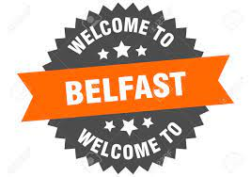

Hotels/Accommodation:
Please go to www.booking.com or other websites for the latest hotel information. Remember, if you source a hotel on a website it is usually cheaper to ring the hotel directly to get a better rate.
There are many new hotels in Belfast and a huge number of apartments and Airbnb for renting. The stadium is in the University quarter of central Belfast.

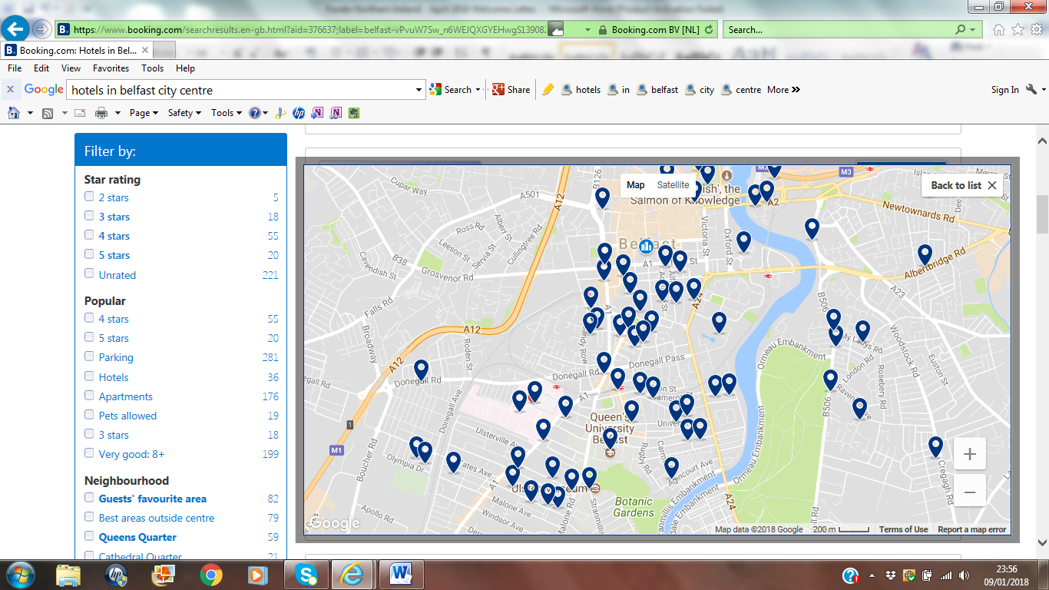

House Belfast Hotel, Europa Hotel, Benedicts Hotel, Etap Hotel Dublin Road, Leonardo Hotel (formerly Jurys Inn Belfast), Ibis, Holiday Inn, Hampton by Hilton, Maldron, Travel Lodge, Hilton, Dukes Hotel, The Cresent Townhouse, The Lansdowne Hotel, Crowne Plaza, Belfast International Youth Hostel, The Ivanhoe Inn are all hotels you should consider. City centre apartments and Airbnb are also close to the stadium. Contact me if you need assistance.

Taxis:
Taxis are cheap and plentiful in Belfast. I recommend Valuecabs 0044(0)28 90 80 90 80 or fonaCab 0044(0)2890 666 666 or Uber. Download their apps. If you use their apps to book a taxi, your booking is prioritised above all others.

Restaurants:
There are a huge number of restaurants in central Belfast with all the usual brand names in the Botanic area not far from the stadium. For Pizza, Villa Italia just opposite or Scalini’s on Botanic Avenue is the best close by. Nu Delhi Indian restaurant and Zen Japanese/Chinese restaurants are delights. Contact me if you need assistance (advance booking is advisable for groups on Saturday evenings).

Bars:
The Crown Bar and Robinsons and Fibber Magee’s on Gt. Victoria St, Revolucion de Cuba Arthur St, Benedicts Hotel Bradbury Place, and The Doffer Bar in Ten Square Hotel Donegall Square South are places to go later on in central Belfast, but there are many bars and restaurants in the city centre.

Airports:
Belfast is serviced by 2 airports. Belfast International Airport BFS (easyJet, Jet2.com, Ryanair, TUI) is 11 miles north of the city and has direct buses every 20 minutes to and from the Europa Bus Centre (behind the Europa Hotel) which is in the centre of Belfast. Tickets cost around £5 per person. Taxis from this airport are expensive. Belfast City Airport (George Best) BHD, Aer Lingus Regional, British Airways, easyJet, KLM, Loganair, Lufthansa ) is in the city, only 3 miles for the city centre. There is a regular bus service to and from this also. Taxis from this airport are reasonable and plentiful outside the door (ask an airport official).
International flights are mostly routed through the London airports Heathrow, Stanstead, Gatwick, Luton and Manchester. I can arrange transport for your team if you wish.

Hospitals:
Belfast has 4 main hospitals, The Royal Victoria, The Belfast City, The Ulster and The Mater Hospitals. The Belfast City Hospital is 5 minutes from the stadium, The Royal Victoria is 7 minutes.

Currency:
Sterling (GBP) is the currency of N Ireland. All major credit cards are accepted throughout the city and Autobanks/Cash machines are numerous.

Did You Know?

Belfast is Northern Ireland’s largest city with a population of some 330000. Northern Ireland has a population of 1.7m. Belfast is a maritime city.
Belfast was the largest linen producing centre in the world.
The Titanic was built in Belfast and today the city still has the largest cranes in the world. When in Belfast one should visit the Titanic Visitor Centre https://www.titanicbelfast.com right where the ship was designed and built "This is one of the most well-thought-out Titanic museums in the world. It’ really quite phenomenal. It’s a magnificent, dramatic building; it’s the biggest Titanic exhibit in the world."

Famous people from Belfast and Northern Ireland:

American Presidents: The ancestors of 7 American Presidents are from N Ireland; Andrew Jackson, James Buchanan, Chester A. Arthur, Ulysses S. Grant, William McKinley, Theodore Roosevelt, Woodrow Wilson.

The American Declaration of Independence was first printed by John Dunlap from Strabane in N. Ireland.

Actors: Ciaran Hinds (Harry Potter, Game of Thrones) Liam Neeson (Schindler’s List, Star Wars, Taken), Jamie Dornan (Fifty Shades of Grey).

Musicians: Van Morrison, Snow Patrol, Gary Lightbody.

Writers: CS Lewis, (The Chronicles of Narnia), Seamus Heaney.

Sports People: George Best (Man United & N. Ireland), Rory McIlroy World No.1 golfer, Lady Mary Peters Olympic Pentathlon Champion Munich ‘72, Graeme McDowell champion golfer, Wayne McCullough WBC world boxing champion, Carl Frampton, WBA & IBF (2 weight) world boxing champion. Darren Clarke British Open Golf Champion, Hurricane Higgins World Snooker Champion, Wille John McBride undefeated captain of British Lions Rugby Team. Joey Dunlop 9 times World road racing champion, Jonathan Rae 6 times World superbike champion. Eddie Irvine, Ferrari F1 Team.

Inventors:
Hans Sloane invented milk chocolate (Sloane Square, London)
John Dunlop invented Dunlop Tyres.
Frank Pantridge invented the portable defibrillator now used worldwide.
Ernest Walton split the atom in 1930.
Harry Ferguson invented the first modern tractor Massey-Ferguson and the first F1 Four-wheel drive racing car.
William McCrum invented the Penalty Kick in soccer/football.
AT Stewart opened retail stores to become America’s 3rd richest man.
James Murray invented Milk of Magnesia and artificial fertiliser.
William Clanny invented the safety lamp for underground mining.
John Stephenson invented the streetcar now used globally in cities.
William Thompson invented Absolute Zero temperature and the compass.
William & Anthony Traill invented the first electric tramway.
Dr Wallace Dinsmore was part of a team, which revealed the side effect of a drug intended to treat angina. It was called Viagra.

Welcome to Belfast.

